CHAPTER 3
STATISTICAL DESCRIPTION OF DATA

SECTION EXERCISES
3.1 c/a/m = 613.48/30 = $20.449. Median = $20.495, the average of the two values in the middle when the data are arranged in order of size.

3.2 c/a/m = 894/20 = 44.70 goals per season. Median = 44.50, average of the two values in the middle when the data are arranged in order of size.

3.3 c/a/m = 1141/20 = 57.05 visitors. Median = 57.50, average of the two values in the middle when the data are arranged in order of size. The mode is 63. There were three different days with 63 visitors.

3.4 c/a/m = 198/10 = 19.8. Median = 18.50, average of the two values in the middle when the data are arranged in order of size. The mode is 30. There were two cartoons that had 30 incidents.

3.5 c/a/m = 138.59/20 = 6.93. Median = 7.095, average of the two values in the middle when the data are arranged in order of size.

3.6 c/a/m = 972.21/15 = $64.81. Median = $65.50, the middle value when the data are arranged in order of size.

3.7 c/a/m = 838/22 = 38.1 yrs. Median = 36.5 yrs., average of the two values in the middle when the data are arranged in order of size.

3.8 c/a/d Expressing dollars and employees in thousands, the weighted mean expenditure per employee is

= $49,370.70

3.9 c/a/m = 90(0.35) + 78(0.45) + 83(0.20) = 83.2

3.10 d/p/d
a. Motorcyclists usually ride 1 to a motorcycle, so this would be the most frequent value.
b. Mean will be greater, because there is sometimes more than one rider, but always at least one.
c. Mean will be greater, because the distribution is skewed to the right.

3.11 d/p/d
a. Mean will be higher since salaries are usually skewed to the right. Management will emphasize
the mean to make the present wage situation look brighter.
b. The union representative will wish to make the present wage situation look worse and therefore will
emphasize the median.

3.12 c/c/m The Minitab printout is shown below.

Descriptive Statistics: Acad, LawJud

Variable N N* Mean SE Mean StDev Minimum Q1 Median Q3
Acad 50 0 3.6080 0.0851 0.6020 2.7000 3.1750 3.4000 4.1250
LawJud 50 0 3.8200 0.0740 0.5233 2.9000 3.4000 3.7000 4.3250

Variable Maximum
Acad 4.8000
LawJud 4.8000

In each set of ratings, the mean exceeds the median. Each distribution is positively skewed.

3.13 c/c/m The Minitab and Excel printouts are shown below.

Descriptive Statistics: PSI

Variable N Mean Median TrMean StDev SE Mean
PSI 100 398.86 396.75 398.64 19.58 1.96

Variable Minimum Maximum Q1 Q3
PSI 351.70 454.50 385.18 414.53

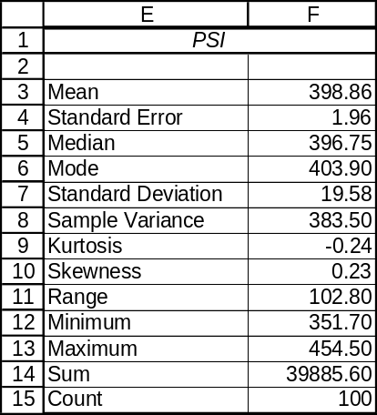
The mean exceeds the median. The distribution is positively skewed.

3.14 c/c/m
Descriptive Statistics: absent by gender

Variable gender N Mean Median TrMean StDev
absent 1 50 8.040 8.000 8.000 3.326
2 50 10.520 10.500 10.568 2.589

Variable gender SE Mean Minimum Maximum Q1 Q3
absent 1 0.470 1.000 17.000 5.750 10.000
2 0.366 3.000 16.000 9.000 12.000

The mean number of absences for female employees is less than that for males. The median for the female employees is also lower. For each gender, the mean exceeds the median and the distribution is positively skewed.

3.15 c/c/m
Descriptive Statistics: age by gender

Variable gender N Mean Median TrMean StDev
age 1 50 40.62 39.00 40.70 11.03
2 50 41.08 41.50 41.05 9.95

Variable gender SE Mean Minimum Maximum Q1 Q3
age 1 1.56 19.00 60.00 32.75 50.25
2 1.41 19.00 63.00 35.00 46.50

The mean age for female employees is less than that for males. The median for the female employees is also lower. For females, the mean age exceeds the median and the distribution is positively skewed.

3.16 d/p/d An ad claim such as "Get up to 70% more miles per gallon by using product x." Most cars tested may have obtained little or no increase in mpg.

3.17 c/a/m Range = 75 - 36 = 39 visitors. MAD = 207.00/20 = 10.35 visitors.
s² = 2922.95/19 = 153.84, and s = 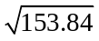= 12.40 visitors.

3.18 c/a/m Range = 30 - 11 = 19 incidents. MAD = 62.0/10 = 6.2 incidents.
s² = 475.60/9 = 52.84, and s = 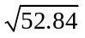= 7.27 incidents.

3.19 c/a/m
a. μ = 203.8/7 = 29.11 million visitors. Median = 22.4 million visitors. Range = 61.7 - 17.2 = 44.5 million visitors.
Midrange = (61.7 + 17.2)/2 = 39.45 million visitors.
b. MAD = 90.943/7 = 12.99 million visitors.
c. σ² = 1668.769/7 = 238.396, σ = 15.44 million visitors.

3.20 c/a/m
a. = 229/11 = 20.82 cents. Median = 18 cents. Range = 55 - 2 = 53 cents. Midrange = (2 + 55)/2 = 28.5 cents.
b. MAD = 133.454/11 = 12.13 cents.
c. s² = 2553.6/10 = 255.36, and s = 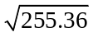= 15.98 cents

3.21 c/a/m
a. = 272/10 = 27.2 mpg. Median = (27 + 29)/2 = 28 mpg. Range = 40 - 10 = 30 mpg.
Midrange = (10 + 40)/2 = 25 mpg.
b. MAD = 56/10 = 5.6 mpg.
c. s² = 583.6/9 = 64.84, and s = 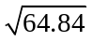= 8.052 mpg.

3.22 c/a/m
a. = 511.20/8 = 63.9 percent. Median = 67.20 percent, average of the two values in the middle when the data are arranged in order of size.
Range = 79.1 - 43.9 = 35.2 percent. Midrange = (79.1 + 43.9)/2 = 61.5 percent.
b. MAD = 73.0/8 = 9.125 percent.
c. s² = 965.58/7 = 137.94, and s = 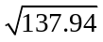= 11.74 percent.

3.23 c/a/m With the data arranged in order of size:
First quartile is in ranked position (11 + 1)/4 = 3; Q₁ = first quartile = 7
Second quartile is in ranked position 2(11 + 1)/4 = 6; Q₂ = second quartile = 18
Third quartile is in ranked position 3(11 + 1)/4 = 9; Q₃ = third quartile = 30
Interquartile range = 30 - 7 = 23; quartile deviation = 23/2 = 11.5

3.24 c/a/m With the data arranged in order of size:
First quartile is in ranked position (10 + 1)/4 = 2.75; Q₁ = 21(0.25) + 23(0.75) = 22.5
Second quartile is in ranked position 2(10 + 1)/4 = 5.5; Q₂ = 27(0.5) + 29(0.5) = 28
Third quartile is in ranked position 3(10 + 1)/4 = 8.25; Q₃ = 32(0.75) + 33(0.25) = 32.25
Interquartile range = 32.25 - 22.5 = 9.75; quartile deviation = 9.75/2 = 4.875

3.25 c/c/m a. and c. The Excel and Minitab descriptive statistics are shown below.
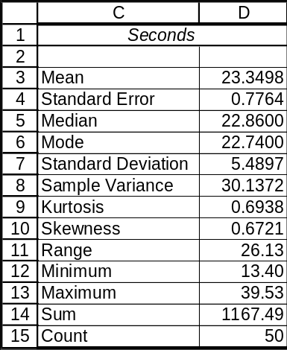

Descriptive Statistics: Seconds

Variable N Mean Median TrMean StDev SE Mean
Seconds 50 23.350 22.860 23.089 5.490 0.776

Variable Minimum Maximum Q1 Q3
Seconds 13.400 39.530 19.095 26.718

The midrange is (13.40 + 39.53)/2 = 26.465

b. The mean absolute deviation must be calculated separately. It is 215.809/50 = 4.316 seconds.

3.26 c/c/m a. and c. The Excel and Minitab descriptive statistics are shown below.
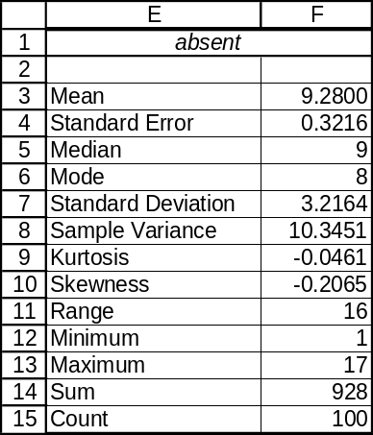

Descriptive Statistics: absent

Variable N Mean Median TrMean StDev SE Mean
absent 100 9.280 9.000 9.300 3.216 0.322

Variable Minimum Maximum Q1 Q3
absent 1.000 17.000 8.000 12.000

The midrange is (1 + 17)/2 = 9

b. The mean absolute deviation must be calculated separately. It is 255.12/100 = 2.55 absences.

3.27 c/c/m a. and c. The Excel and Minitab descriptive statistics are shown below.
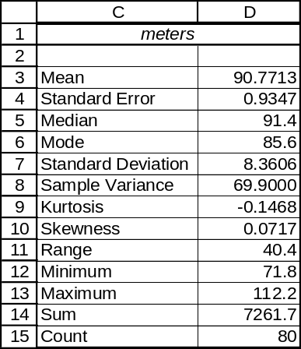

Descriptive Statistics: meters

Variable N Mean Median TrMean StDev SE Mean
meters 80 90.771 91.400 90.742 8.361 0.935

Variable Minimum Maximum Q1 Q3
meters 71.800 112.200 85.025 96.275

The midrange is (71.8 + 112.2)/2 = 92.0

b. The mean absolute deviation must be calculated separately. It is 536.3575/80 = 6.70 meters.

3.28 c/a/m
a. The median is approximately 37.5 defects per day. The first quartile is approximately 37 defects per day. The third quartile is approximately 39 defects per day.
b. The asterisks at the right are outliers, indicating two days on which unusually large numbers of defects were produced. The production supervisor should try to determine if anything out of the ordinary was happening at the plant on those days.
c. The distribution is positively skewed.

3.29 c/a/e
a. At least (1-(1/2.5²))*100 = 84%
b. At least (1-(1/3²))*100 = 88.89%
c. At least (1-(1/5²))*100 = 96%

3.30 c/a/m Standardized data values: -1.18, -0.99, -0.87, -0.55, -0.36, -0.18, -0.05, 0.26, 0.57, 1.20, and 2.14; 90.9% of them are within 1.5 standard deviation units of the mean. Chebyshev's Theorem states that at least (1 – (1/1.5²))*100 = 55.6% should fall within that interval, and these results support the theorem.

3.31 c/a/m Standardized data values: -2.14, -0.77, -0.52, -0.02, -0.02, 0.22, 0.35, 0.60, 0.72, and 1.59; 90% of them are within 2.0 standard deviations of the mean. Chebyshev's Theorem states that at least
(1 – (1/2²))*100 = 75% should fall within that interval, and these results support the theorem.

3.32 c/a/m Using the empirical rule:
a. 95%. This is the percentage of values that are within ±2 standard deviations of the mean.
b. 16%, or 50% - 34%. Recall that 68% of the values are within ±1 standard deviation of the mean.
c. 2.5%, or 50% - 47.5%; 95% of the values are within ±2 standard deviations of the mean.
d. 81.5%, obtained by 34% (the area between the mean and 11,500) plus 47.5% (the area from the mean to 13,000).

3.33 c/a/m Using the empirical rule:
a. 68%. This is the percentage of values that are within ±1 standard deviation of the mean.
b. 2.5%, or 50% - 47.5%; 95% of the values are within ±2 standard deviations of the mean.
c. 84%, or 50% (the area to the left of the mean) plus 34% (the area from the mean to 580).
d. 13.5%, obtained by 47.5% (the area between the mean and 680) minus 34% (the area between the mean and 580).

3.34 c/a/m Coefficient of variation = s/ = (140/1235)*100 = 11.34% for data set A. Coefficient of variation = s/ = (1.87/15.7)*100 = 11.91% for data set B. Set B has greater relative dispersion.

3.35 c/a/m Coefficient of variation = s/ = (87/315)*100 = 27.62% for Barnsboro. Coefficient of variation = s/ = (1800/8350)*100 = 21.56% for Wellington. Barnsboro has greater relative dispersion.

3.36 c/c/m
a. Box-and-whisker plot and listing of key descriptors. The distribution is positively skewed.
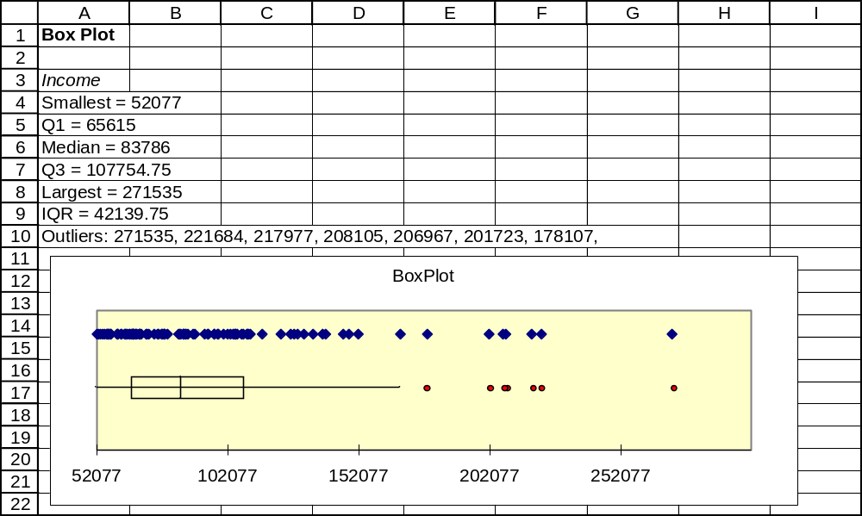

b. A portion of the data and standardized data, and descriptive statistics for the 100 standardized values.
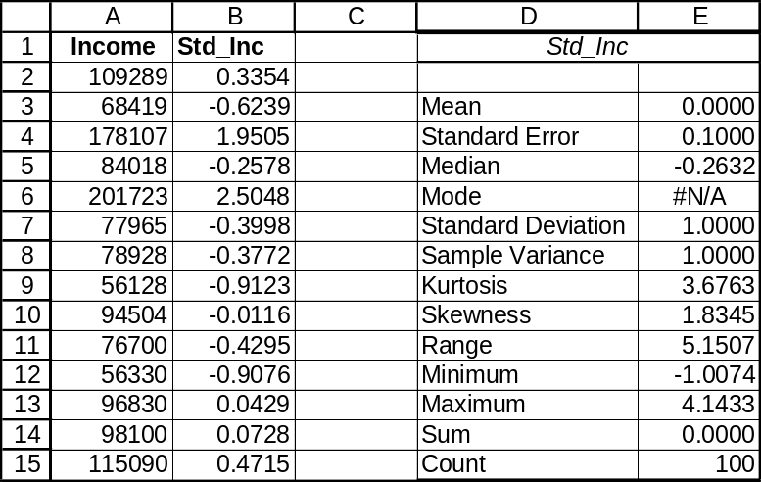

3.37 c/c/m
a. Box-and-whisker plot and listing of key descriptors. The distribution is positively skewed.
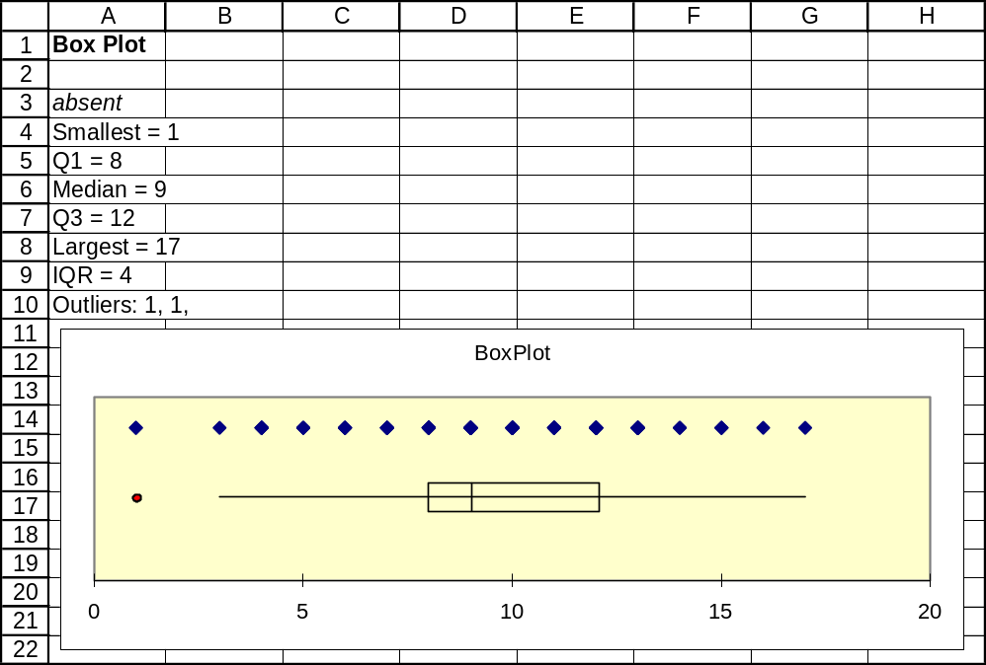

b. A portion of the data and standardized data, and descriptive statistics for the 100 standardized values.
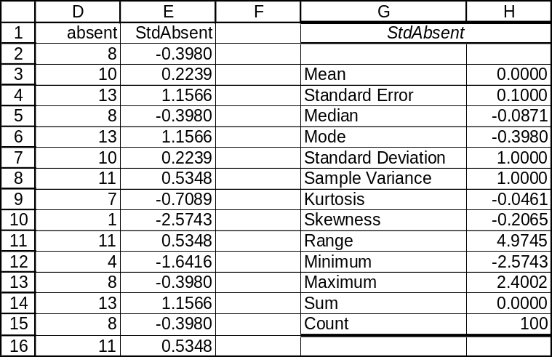

3.38 c/c/m
a. Box-and-whisker plot and listing of key descriptors. The distribution is positively skewed.
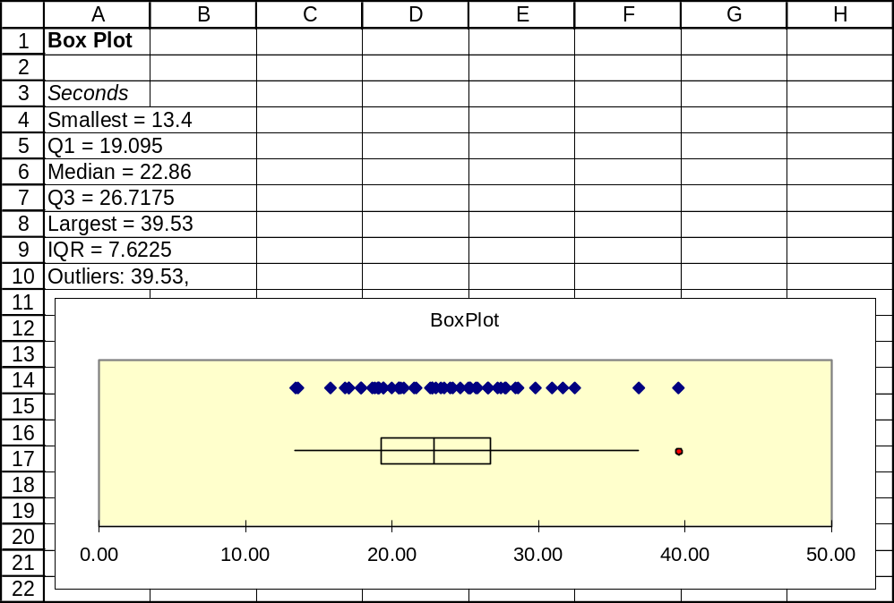

b. A portion of the data and standardized data, and descriptive statistics for the 50 standardized values.
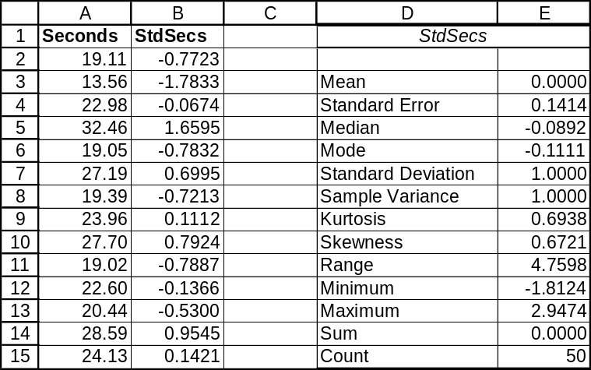

3.39 c/a/d
a. Frequency distribution with classes having widths of 1:
class | m_{i} | f_{i} | f_{i}m_{i} | f_{i}m_{i}²
4 - under 5 | 4.5 | 2 | 9.0 | 40.50
5 - under 6 | 5.5 | 4 | 22.0 | 121.00
6 - under 7 | 6.5 | 3 | 19.5 | 126.75
7 - under 8 | 7.5 | 6 | 45.0 | 337.50
8 - under 9 | 8.5 | 3 | 25.5 | 216.75
9 - under 10 | 9.5 | 2 | 19.0 | 180.50
 |  | sum = 20 | sum = 140.0 | sum = 1023.0

The estimates are 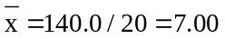 and 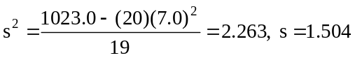

b. The mean and standard deviation for the actual data were 6.930 and 1.399, respectively.

c. Frequency distribution with classes having widths of 0.5:
class | m_{i} | f_{i} | f_{i}m_{i} | f_{i}m_{i}²
4 - under 4.5 | 4.25 | 0 | 0.00 | 0.0000
4.5 - under 5.0 | 4.75 | 2 | 9.50 | 45.1250
5.0 - under 5.5 | 5.25 | 3 | 15.75 | 82.6875
5.5 - under 6.0 | 5.75 | 1 | 5.75 | 33.0625
6.0 - under 6.5 | 6.25 | 1 | 6.25 | 39.0625
6.5 - under 7.0 | 6.75 | 2 | 13.50 | 91.1250
7.0 - under 7.5 | 7.25 | 5 | 36.25 | 262.8125
7.5 - under 8.0 | 7.75 | 1 | 7.75 | 60.0625
8.0 - under 8.5 | 8.25 | 1 | 8.25 | 68.0625
8.5 - under 9.0 | 8.75 | 2 | 17.50 | 153.1250
9.0 - under 9.5 | 9.25 | 2 | 18.50 | 171.1250
9.5 - under 10.0 | 9.75 | 0 | 0.00 | 0.0000
 |  | sum = 20 | sum =139.0 | sum = 1006.25

The estimates are now 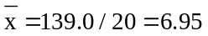and 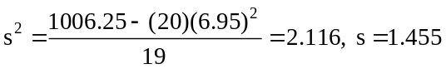
The approximations have improved.

d. If each data value were the midpoint of its own class, the approximate values would be identical to the exact values.

3.40 c/a/d
m_{i} | f_{i} | f_{i}m_{i} | f_{i}m_{i}²
10 | 7 | 70 | 700
20 | 9 | 180 | 3,600
30 | 12 | 360 | 10,800
40 | 14 | 560 | 22,400
50 | 13 | 650 | 32,500
60 | 9 | 540 | 32,400
70 | 8 | 560 | 39,200
80 | 11 | 880 | 70,400
90 | 10 | 900 | 81,000
100 | 7 | 700 | 70,000
 | sum = 100 | sum = 5400 | sum = 363,000

Approximate values are 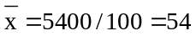 and 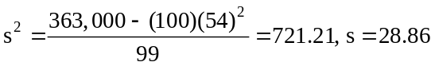

3.41 c/a/d
m_{i} | f_{i} | f_{i}m_{i} | f_{i}m_{i}²
5 | 25 | 125 | 625
15 | 17 | 255 | 3,825
25 | 15 | 375 | 9,375
35 | 9 | 315 | 11,025
45 | 10 | 450 | 20,250
55 | 4 | 220 | 12,100
 | sum = 80 | sum = 1740 | sum = 57,200

Approximate values: 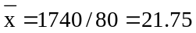 and 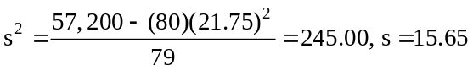

3.42 d/p/e The coefficient of determination is the proportion of the variation in y that is explained by the best-fit linear equation. It is a measure of the strength of the relationship between the variables.

3.43 c/a/e Because the variables are inversely related, r will be negative. Thus, r will be the negative square root of 0.64, or r = -0.8.

3.44 c/c/m
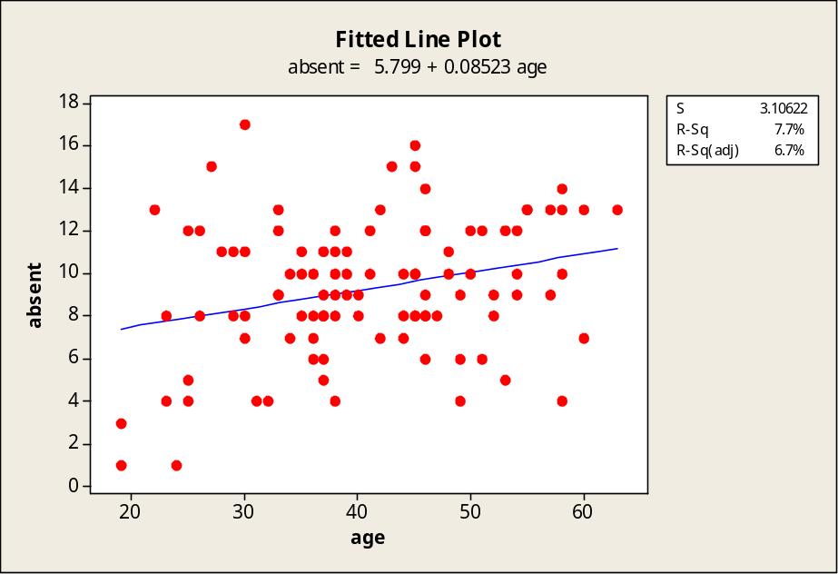
The equation explains 7.7% of the variation in the number of absences. The coefficient of correlation is the positive (since the slope is positive) square root of 0.077, or r = 0.277.

3.45 c/c/m
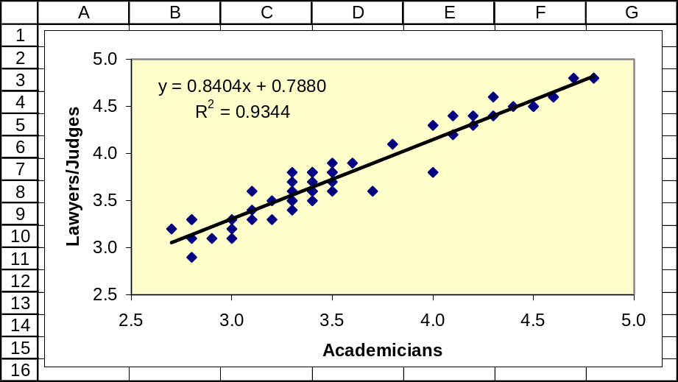
Ratings from the academicians explain 93.44% of the variation in the ratings of the lawyers/judges.
The coefficient of correlation is the positive (since the slope is positive) square root of 0.9344,
or r = 0.967.

3.46 c/c/m
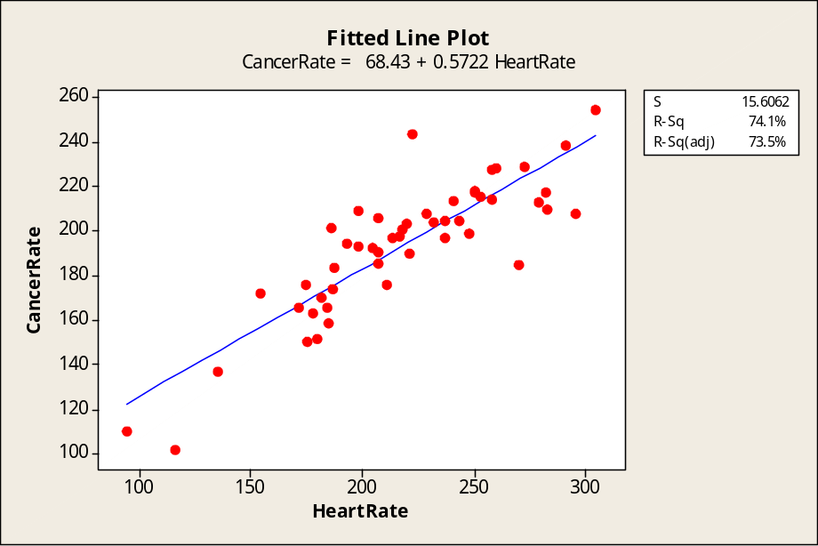
The equation explains 74.1% of the variation in the cancer rates. The coefficient of correlation is the positive (since the slope is positive) square root of 0.741, or r = 0.861.

3.47 c/c/m
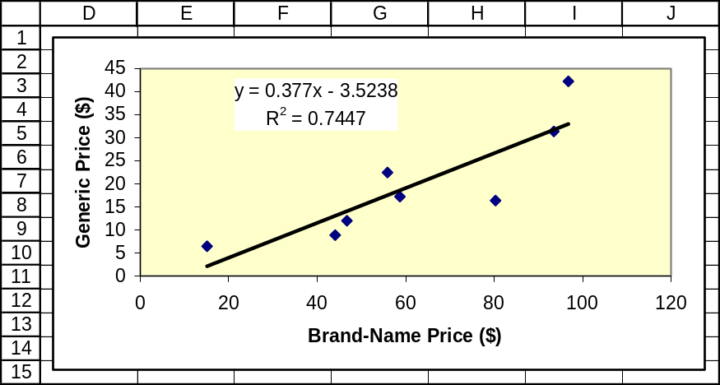
The equation explains 74.47% of the variation in the generic prices. The coefficient of correlation is the positive (since the slope is positive) square root of 0.7447, or r = 0.863.

CHAPTER EXERCISES
3.48 c/a/m = (1.25 + 2.36 + 2.50 + 2.15 + 4.55 + 1.10 + 0.95)/7 = $2.12. Yes, the service to the first seven customers was profitable.

3.49 c/a/d = (5(50) + 2(30) + 4(60) + 10(20))/(50 + 30 + 60 + 20) = $4.69

3.50 c/a/m
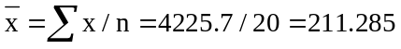; Median = (206.4 + 210.6)/2 = 208.5; There is no mode.

3.51 c/a/m 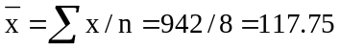 Median = (113 + 122)/2 = 117.5; There is no mode.

3.52 c/a/m
a. 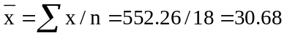mph. Median = (30 + 30)/2 = 30 mph. b. Mode = 30 mph.

3.53 d/p/m The distribution is not symmetrical. It is positively skewed.

3.54 c/p/d
a. The mean exceeds the median and, based on the rough character-graph boxplot shown below, the
distribution appears to be very slightly positively skewed.
---------
----------I + I------------
---------
-----+---------+---------+---------+-----
50 100 150 200

b. Approximately 2.5%, obtained by 50% (the area to the left of the mean) minus 47.5% (the area between 64 cups and the mean). According to the empirical rule, approximately 95% of the data values will lie within 2 standard deviations of the mean; 64 cups is about two standard deviations less than the mean.

3.55 d/p/m
a. Since all values should be increased by 0.1, the sample mean will increase by 0.1 to 3.1 lbs. Since the relative variation is unchanged, the sample standard deviation will still be 0.5 lbs.
b. Using the empirical rule, this would be 4.1 lbs., obtained by 3.1 + 2(0.5). Approximately 95% of the data values will lie within 2 standard deviations of the mean.

3.56 c/a/m
a. 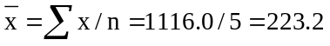stoppages. Median = 235 stoppages (3rd value when data are
arranged in order of size).
Range = 424 – 44 = 380 stoppages
Midrange = (44 + 424)/2 = 234.0 stoppages

b.

c. 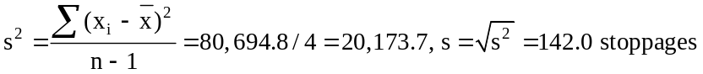

3.57 c/a/m
a. 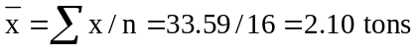, Median = (2.08 + 2.15)/2 = 2.115 tons.
Range = 2.31 - 1.85 = 0.46 tons Midrange = (1.85 + 2.31)/2 = 2.08 tons.

b.

c. 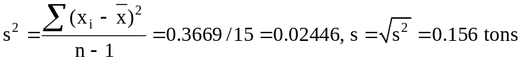

3.58 c/a/m The median is approximately 99 gallons. The first quartile is approximately 92 gallons.
The third quartile is approximately 104 gallons. The range is approximately 120 - 80 = 40 gallons.
The distribution appears to be slightly negatively skewed.

3.59 c/a/m The median is approximately 120 watts. The first quartile is approximately 116 watts.
The third quartile is approximately 124 watts. The range is approximately 130 - 110 = 20 watts.
The distribution appears to be symmetrical.

3.60 c/a/m
a. 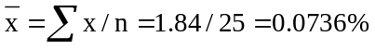 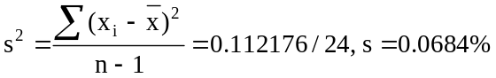

b. Chebyshev's Theorem states that at least (1 - (1/1.5²))*100 = 55.6% should fall within 1.5 standard deviation units. For this data, all except the largest three values, or 88% of the data set, fall within 1.5 standard deviation units.
c. Coefficient of variation = (s/)*100% = (0.0684/0.0736)*100% = 92.9%

3.61 c/a/m Exercise 3.57: coefficient of variation = (s/ )*100 = (0.156/2.10)*100 = 7.43 %
Exercise 3.60: coefficient of variation = (s/)*100 = (0.0684/0.0736)*100% = 92.9%
There is greater variation for the data in exercise 3.60.

3.62 c/a/m
m_{i} | f_{i} | f_{i}m_{i} | f_{i}m_{i}²
50 | 27 | 1350 | 67,500
150 | 11 | 1650 | 247,500
250 | 4 | 1000 | 250,000
350 | 1 | 350 | 122,500
450 | 2 | 900 | 405,000
550 | 1 | 550 | 302,500
650 | 0 | 0 | 0
750 | 1 | 750 | 562,500
850 | 1 | 850 | 722,500
950 | 0 | 0 | 0
1050 | 1 | 1050 | 1,102,500
1150 | 1 | 1150 | 1,322,500
 | sum = 50 | sum = 9600 | sum = 5,105,000

Approximate values:

3.63 c/a/m Median = (24 + 25)/2 = 24.5 pages. First Quartile = 22(0.75) + 22(0.25) = 22 pages.
Third Quartile = 29(0.25) + 35(0.75) = 33.5 pages.

Variable N Mean Median TrMean StDev SE Mean
pages 20 25.65 24.50 25.72 8.01 1.79

Variable Minimum Maximum Q1 Q3
pages 11.00 39.00 22.00 33.50

3.64 c/a/m
Class | m_{i} | f_{i} | f_{i}m_{i} | f_{i}m_{i}²
10 - under 20 | 15 | 4 | 60 | 900
20 - under 30 | 25 | 11 | 275 | 6,875
30 - under 40 | 35 | 5 | 175 | 6,125
 |  | sum = 20 | sum = 510 | sum = 13,900

Approximate values: = 510/20 = 25.5 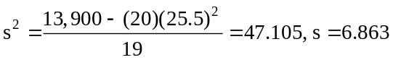

3.65 c/c/m
a. Descriptive statistics.
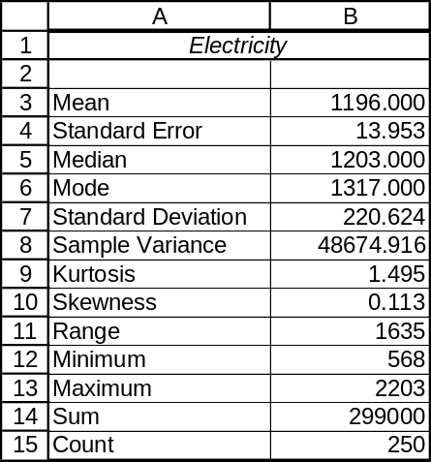

b. Boxplot with interpretation statistics.
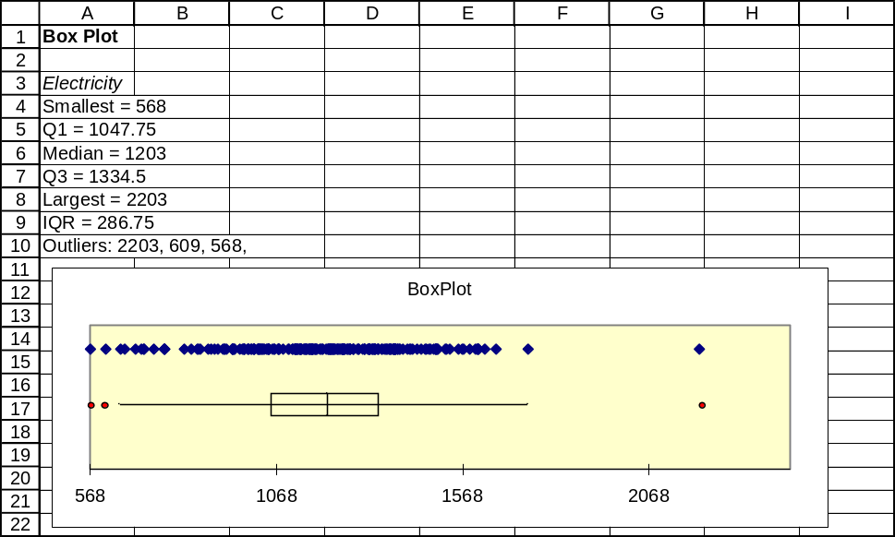

c. As shown in part (b), there are two outlier households ($568 and $609) at the low end and one ($2203) at the high end of electricity expenditures. Energy-conservation officials may wish to examine these households for habits or characteristics that should either be emulated or avoided.

3.66 c/c/m
a. Descriptive statistics.
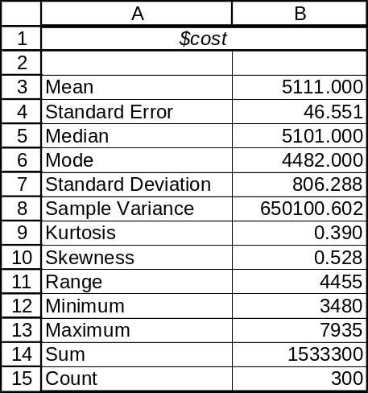

b. Boxplot with interpretation statistics.
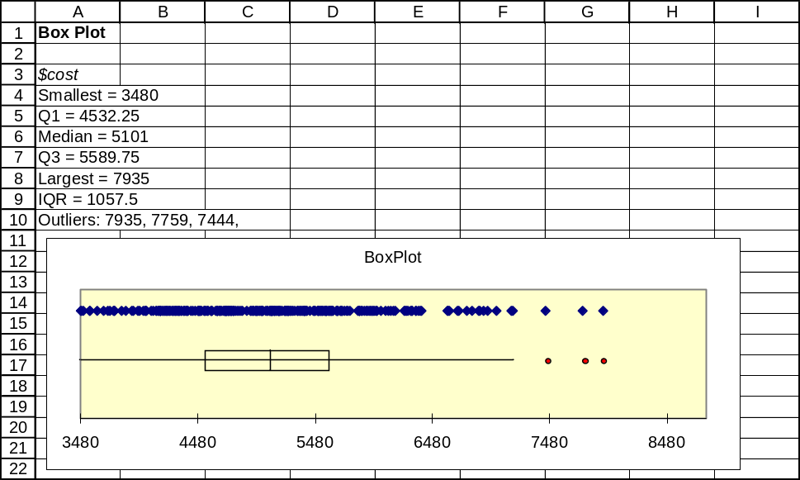

c. As shown in part (b), there are three outlier couples ($7935, $7759, and $7444) at the high end of honeymoon expenditures. Cruise lines, resort areas, and various governmental tourism-promotion agencies could be interested in finding out more about the age, media habits, and other characteristics of these people so as to be able to reach and persuade others like them to spend their honeymoons or vacations at their venues.

3.67 c/c/m
a. Descriptive statistics.
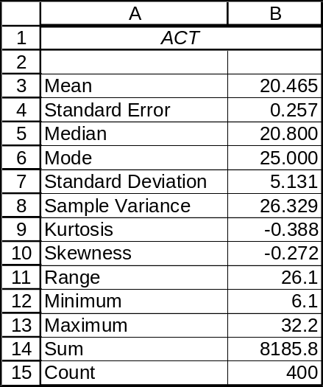

Descriptive Statistics: ACT

Variable N N* Mean SE Mean StDev Minimum Q1 Median Q3
ACT 400 0 20.465 0.257 5.131 6.100 16.800 20.800 24.375

Variable Maximum
ACT 32.200

b. Boxplot with interpretation statistics.
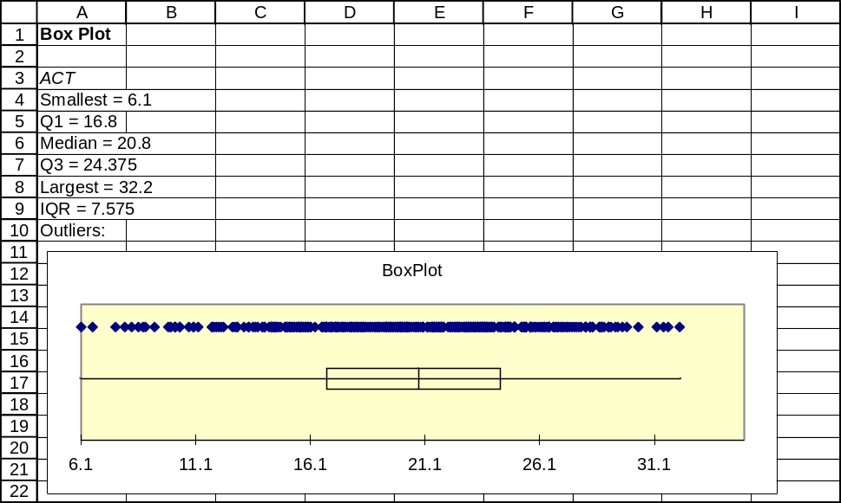

c. A test-taker would have to score 25 (24.375, rounded up) on the math portion to be higher than 75% of the sample members. He or she would have to score 17 (16.8, rounded up) to be higher than 25% of the sample members. These correspond to the third and first quartiles, respectively.

3.68 c/c/m
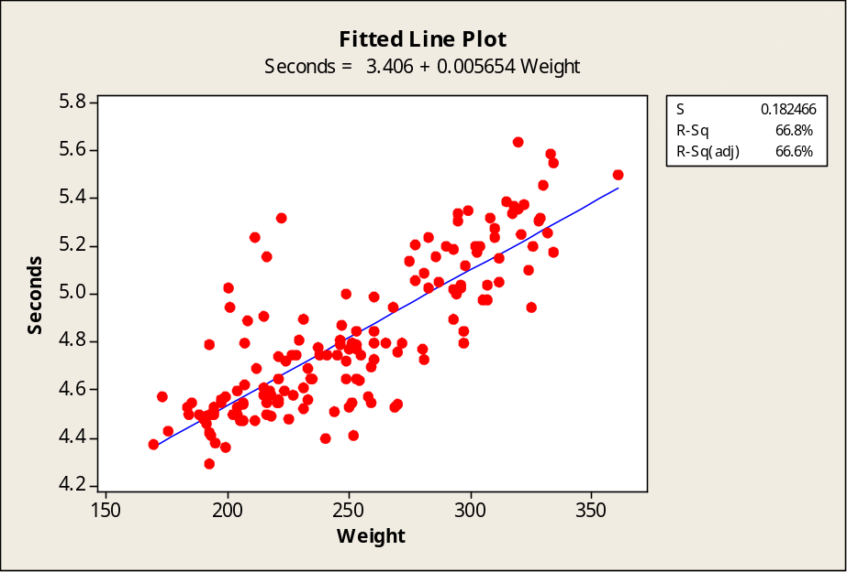
With the linear estimation equation, player weight explains 66.8% of the variation in 40-yard times. Since the slope is positive, the coefficient of correlation is the positive square root of 0.668, or r = 0.82.

3.69 c/c/m
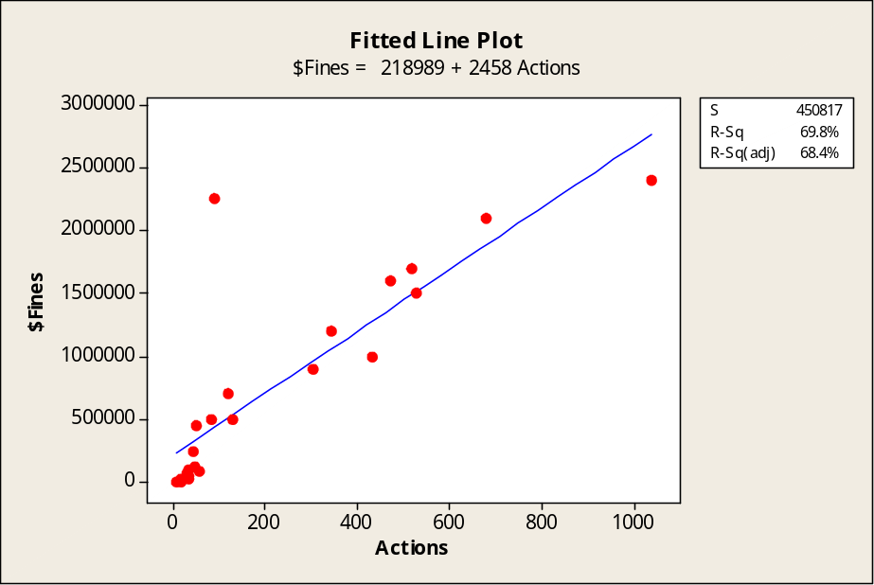
Through the linear estimation equation, the number of actions explains 69.8% of the variation in fine amounts. Because the slope is positive, the coefficient of correlation is the positive square root of 0.698, or r = 0.84.

INTEGRATED CASES

THORNDIKE SPORTS EQUIPMENT

1. Measures of central tendency and dispersion for the new golf balls, using Minitab:

Descriptive Statistics: NewBall

Variable N Mean SE Mean StDev Minimum Q1 Median Q3 Maximum
NewBall 25 251.53 3.57 17.86 223.70 235.45 252.80 264.70 294.10

The mean is 251.53 and the median is 252.80. Both are good measurements to reflect central
tendency. The standard deviation is 17.86, measuring the dispersion of the data.

2. Measures of central tendency and dispersion for the conventional golf balls:

Descriptive Statistics: ConBall

Variable N Mean SE Mean StDev Minimum Q1 Median Q3 Maximum
ConBall 25 238.04 3.86 19.29 201.00 222.45 240.30 254.15 267.90

The mean is 238.04 and the median is 240.30. The standard deviation is 19.29.

3. The mean and median distances traveled by the new ball are considerably larger than the corresponding values for the old ball. This indicates that the new ball is “more lively” than the old ball, and on average travels further. Another indication of a greater distance for the new ball can be seen in the ranges. The range of the new ball is from 223.70 to 294.10; whereas, the range of the old ball is from 201.00 to 267.90. The standard deviations of the samples are relatively similar, with a larger dispersion among the distances of the old ball than the new one.

SPRINGDALE SHOPPING SURVEY

This exercise is based on SHOPPING, the Springdale shopping survey database. There are 30 variables and 150 cases (respondents) in this database. Using Minitab:

1a. Descriptive statistics, including mean and median.

Descriptive Statistics: IMPEXCH, IMPQUALI, IMPPRICE, IMPVARIE, IMPHELP, ...

Variable N Mean SE Mean StDev Minimum Q1 Median Q3
IMPEXCH 150 5.260 0.159 1.947 1.000 4.000 6.000 7.000
IMPQUALI 150 6.293 0.111 1.359 1.000 6.000 7.000 7.000
IMPPRICE 150 6.4267 0.0962 1.1778 1.0000 6.0000 7.0000 7.0000
IMPVARIE 150 5.653 0.113 1.381 1.000 5.000 6.000 7.000
IMPHELP 150 5.160 0.139 1.699 1.000 4.000 6.000 6.000
IMPHOURS 150 5.387 0.129 1.579 1.000 5.000 6.000 7.000
IMPCLEAN 150 5.320 0.132 1.619 1.000 4.000 6.000 7.000
IMPBARGN 150 5.667 0.114 1.398 1.000 5.000 6.000 7.000

Variable Maximum
IMPEXCH 7.000
IMPQUALI 7.000
IMPPRICE 7.0000
IMPVARIE 7.000
IMPHELP 7.000
IMPHOURS 7.000
IMPCLEAN 7.000
IMPBARGN 7.000

1b. In part (a), for all 8 variables, the median exceeds the mean, indicating negative skewness.
The corresponding boxplots, shown below, support this conclusion.
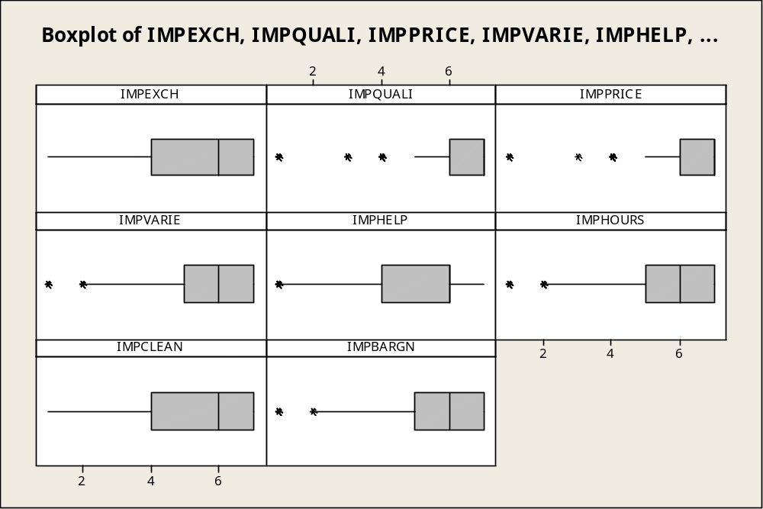

2. Quality and price seem to be the most important attributes in respondents’ choice of a shopping area. Helpful staff, clean store, and convenient hours are the least important attributes.

3. Descriptive statistics for variables 29 and 30.

Descriptive Statistics: RESPHOUS, RESPAGE

Variable N Mean SE Mean StDev Minimum Q1 Median Q3 Maximum
RESPHOUS 150 3.120 0.143 1.757 1.000 1.750 3.000 4.000 8.000
RESPAGE 150 32.05 1.22 14.96 17.00 21.00 26.00 38.25 74.00

 |  | Mean | StDev | Coef. of Variation (StDev/Mean)*l00
C29 | RESPHOUS | 3.120 | 1.757 | 56.3
C30 | RESPAGE | 32.05 | 14.96 | 46.7
Based on the coefficients of variation shown above, C29 (RESHOUS) exhibits greater variation than C30 (RESPAGE).

4. Coefficient of correlation between variables 29 and 30.

Correlations: RESPHOUS, RESPAGE

Pearson correlation of RESPHOUS and RESPAGE = -0.099
P-Value = 0.228

With r = -0.099, (-0.099)²*100 is just 0.98%. Slightly less than 1% of the variation in the number
of persons in the respondent’s household is explained by the respondent’s age.

BUSINESS CASE

BALDWIN COMPUTER SALES (A)

1. The mean score on the screening test is higher for those who did not default, shown in the Minitab printout below as 63.439 versus 56.65.

Descriptive Statistics: Score

Variable Default N Mean SE Mean StDev Minimum Q1 Median
Score 0 205 63.439 0.835 11.954 28.000 54.000 62.000
1 137 56.65 1.06 12.45 32.00 48.00 57.00

Variable Default Q3 Maximum
Score 0 72.000 97.000
1 64.00 88.00

2. The third quartile for those who did not default was 72.00 -- for this group, 75% scored 72.00 or lower on the screening test. If a score of 72.00 had been had been established as a cutoff for receiving a computer loan, 25% of those who repaid would have been denied a loan in the first place. Granting a loan solely on the basis of a screening test score of 72.00 or above would seem to be rather unfair to those students who end up repaying the loan, as 25% of them would not have received the loan they ended up repaying.

3. The Minitab dotplots below visually compare the screening test scores of students who did not default on their computer loan to the scores of those who defaulted. The distribution of screening test scores for those who did not default is most definitely shifted to the right of the distribution of scores for those who did default.
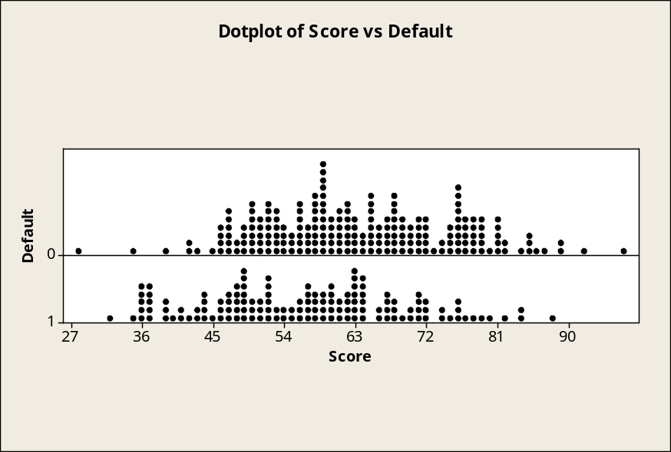

4. Based on the preceding results, the screening test does appear to be potentially useful as one of the factors in helping Baldwin predict whether a given applicant will end up defaulting on his or her computer loan. However, Baldwin might benefit from considering other factors as well -- note that four students with screening test scores well over 72.00 (ranging from the low 80s to the high 80s) ended up defaulting on their computer loans. Also, one of the students who did not default had the lowest screening score of all, shown in the dotplots above as slightly above 27.

